**ASSINGMENT 01**

**QUES 1.**

**Given below is a dictionary having two keys 'Boys' and 'Girls' and having two lists of heights of five Boys and Five Girls respectively as a values associated with these keys.**

**Original dictionary of list : { 'Boys':[72,68,70,69,74] , 'Girls':[63,65,69,62,61] }**

**From the given dictionary of list create the following list of dictionaries:**

**[{'Boys':72,'Girls':63},{'Boys':68,'Girls':65},{'Boys':70,'Girls':69},{'Boys':69,'Girls':62},{'Boys':74,'Girls':61}]**

**CODE:**

org_dict={'Boys':[72,68,70,69,74] ,'Girls':[63,65,69,62,61]}

conv_list=[] *#created a empty list*

*#============main code=====================#*

for b , g in zip(org_dict['Boys'],org_dict['Girls']):

    conv_list.append(

        {

            "Boys":b,

            "Girls":g

        })

*#=========printing the result=============#*

print("Resulting List :")

print(conv_list)

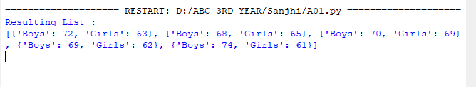**OUTPUT:**